OUTPUT

WEEK 5

* Creating Microservices for account and loan

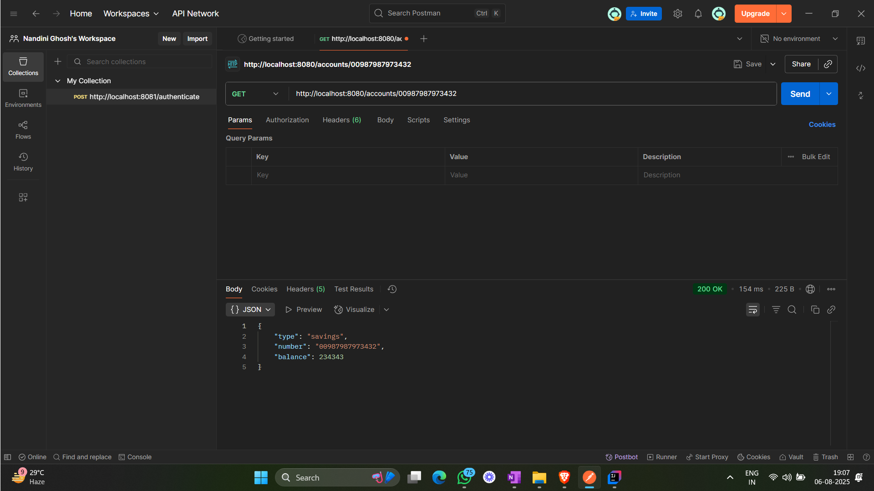

Microservice for account

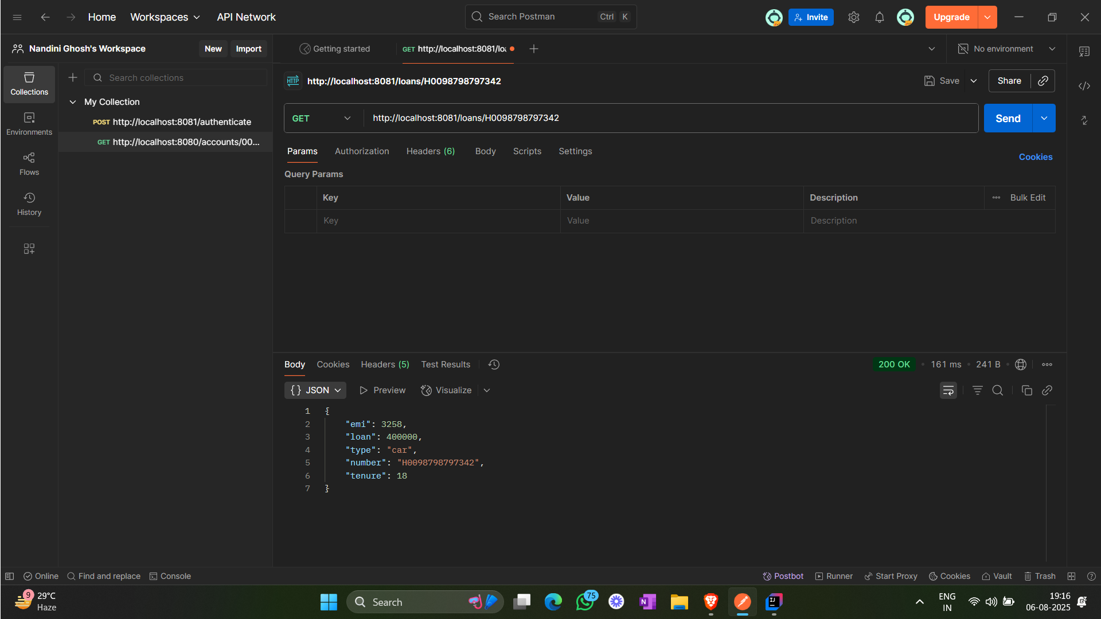

Microservice for loan